Days | Breakfast | Snacks | Lunch | Pudding | Tea
Monday | Milk/Selection of Cereals   | Fresh Fruit Selection  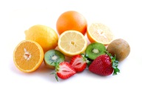 | Spaghetti in Vegetable & Tomato sauce  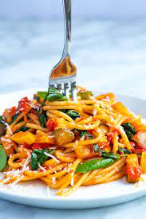 | Yoghurt   | Selection of Sandwiches  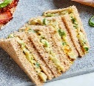
Vegetarian |  |  | Quorn option available
Tuesday | Milk/Selection of Cereals  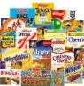 | Fresh Fruit Selection/Toast | Jollof Rice with chicken vegetable stew  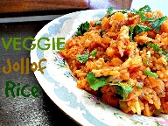 | Fruit cocktail/yogurt  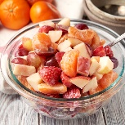 | Hash browns and baked beans    Or Pancakes
Vegetarian |  |  | Quorn option available
Wednesday | Milk/Selection of Cereals  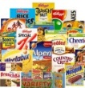 | Fresh Fruit Selection/Toast  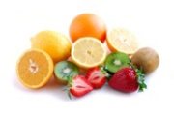 | Mixed Beans and root Vegetables served with herb couscous  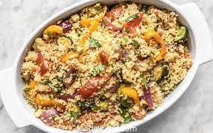 | Water melon  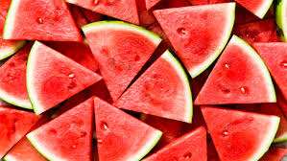 | Tomato soup &Bread & Butter OR Hot cross bun  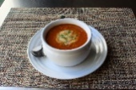  
Vegetarian
Thursday | Milk/Selection of Cereals  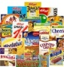 | Fresh Fruit Selection | One pot Pasta in Quorn & Vegetable sauce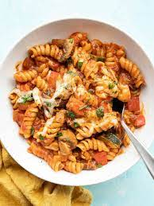 | Yoghurt | Sweetcorn pizza  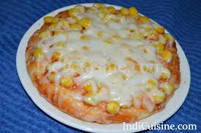
Vegetarian |  |  | Quorn option available
Friday | Milk/Selection of Cereals  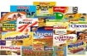 | Fruit Platter | Fish fingers/chicken nuggets with chips and beans   | Rice pudding 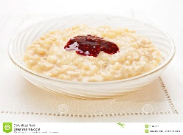 | Chicken noodles  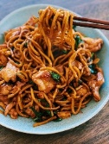  Or Bread & Butter  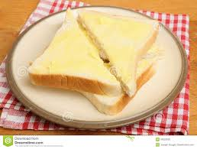
Vegetarian |  |  | Quorn option available | Fresh fruits | Quorn option available

